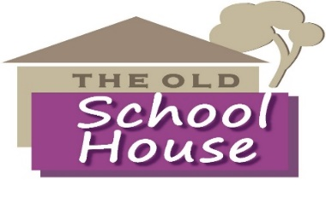
Talk face to face with the experts

Bringing the Specialist Support Providers to the Community
The Leyburn Arts and Community Centre is hosting drop-in sessions on the second Friday of each month at 10.00 am to 12.00 am.
At the drop-in sessions, you will be able to talk face to face in confidence to representatives from:
- Leyburn and District Community Support
- Citizens Advice and Law
- Carers Plus Yorkshire
- Mind
The drop-in sessions are completely free, no appointments are required. If you have a problem you would like to discuss, just pop in and enjoy a free tea/coffee while you talk.
The next drop-in is Friday 12th July at 10.00pm

